I
n this session we will try to understand what is decision table with HIT policy ANY

With the HIT policy ANY, multiple rules can be satisfied. However, all satisfied rules must generate the same output. The decision table result contains only the output of one of the satisfied rules.

Camunda DMN Decision Table HIT policy Any
If multiple rules are satisfied which generate different outputs, the hit policy is violated.

To demonstrate the user of HIT policy ANY, We will model below process and decision table.

1. Process definition (BPMN)
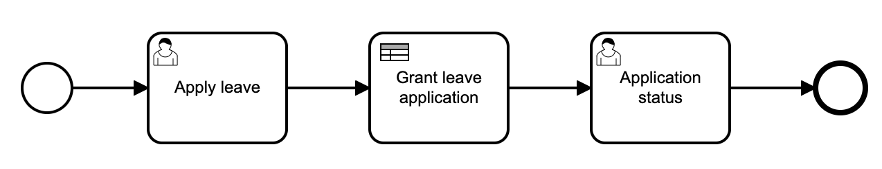

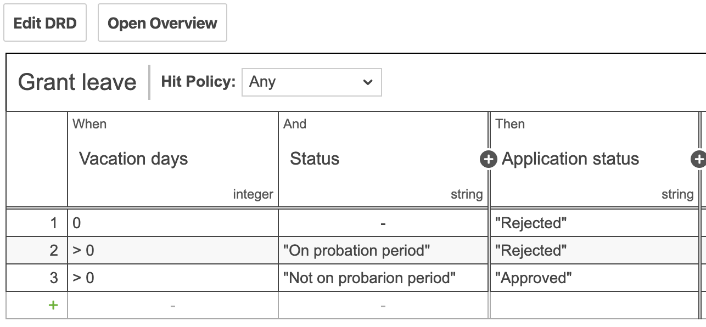
2. Decision table (DMN)
3. Process definition properties
Id: Process_HIT_policy_any
Name: Process HIT Policy Any

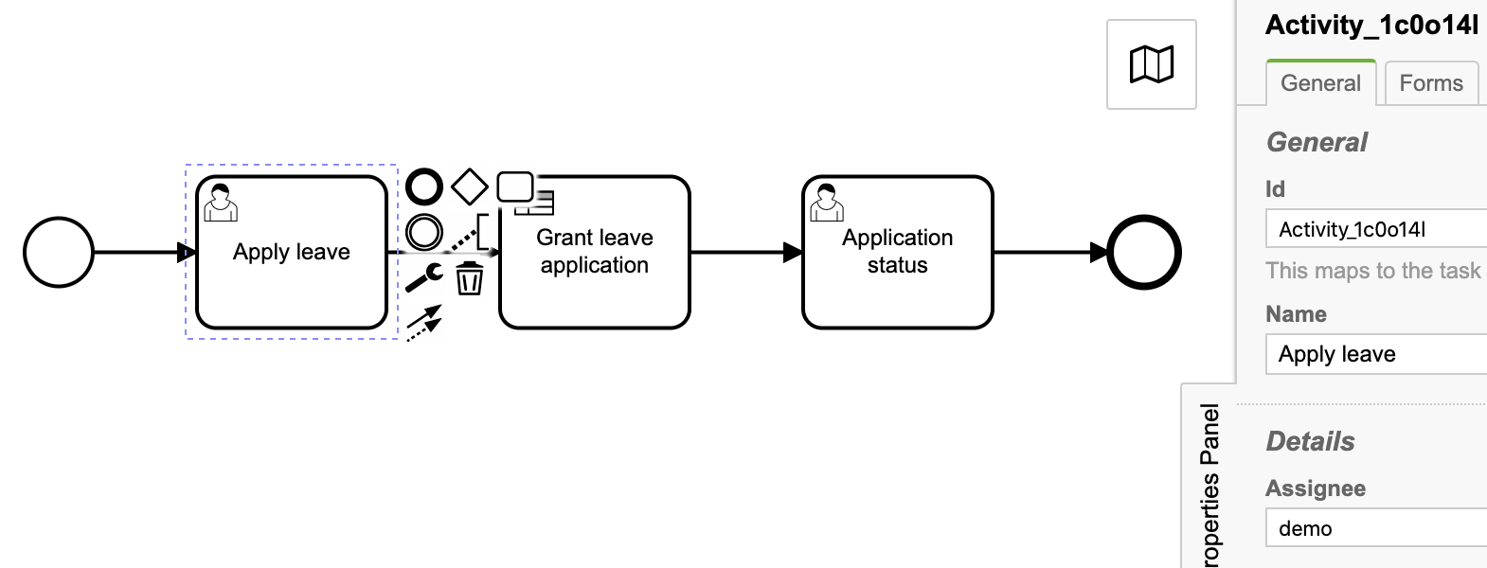
3.1. User task: Guest Registration
Id: Activity_1c0o14l
Name: Apply leave
Assignee: demo
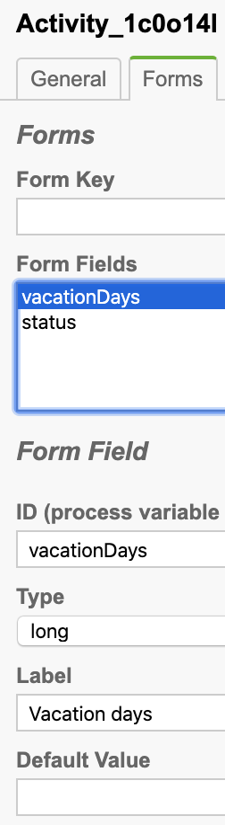
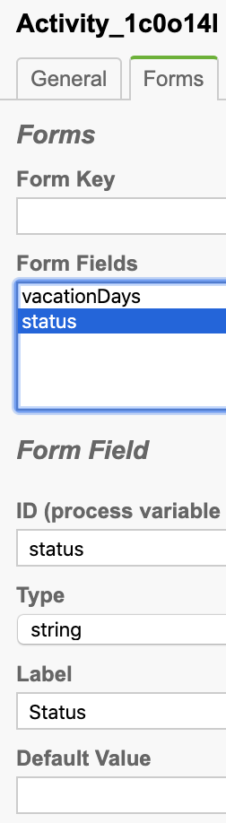
Task form

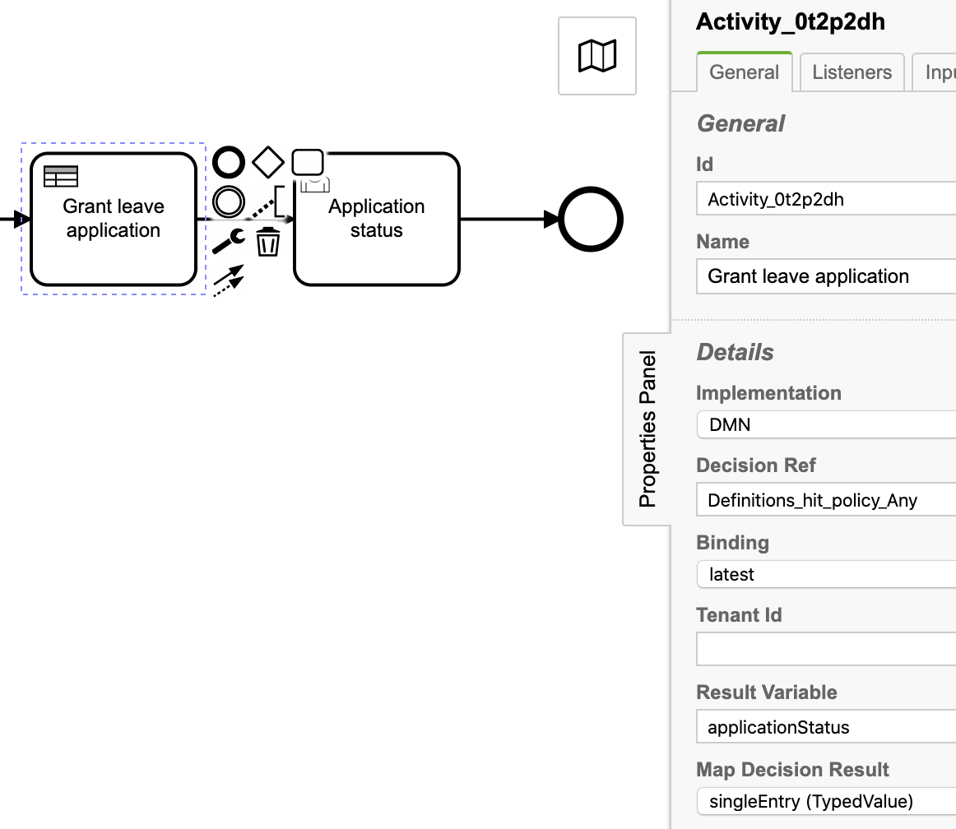
3.2. Business rule task: Decide Leave

Id: Activity_0t2p2dh
Name: Grant leave application
Implementation: DMN
Decision Ref: Definitions_hit_policy_Any
Binding: latest
Result Variable: applicationStatus
Map Decision Result: singleEntry (TypedValue)

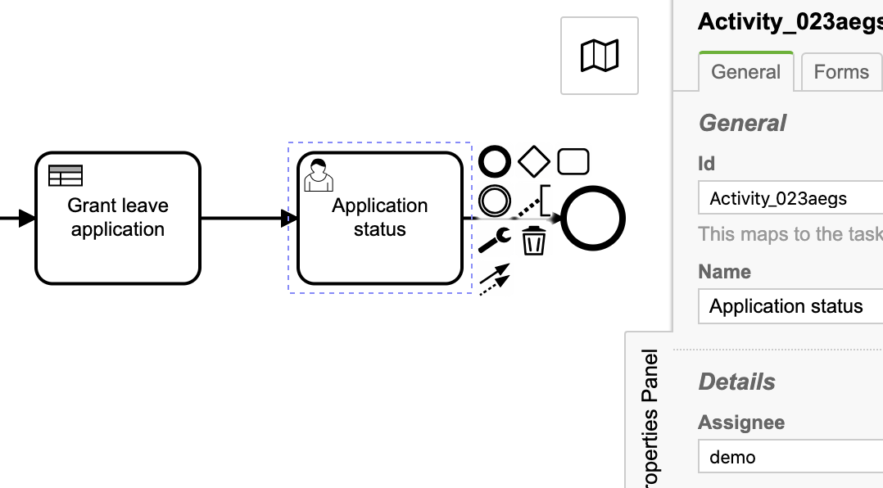
3.3. User task: Application status
Id: Activity_023aegs
Name: Application status
Assignee: demo

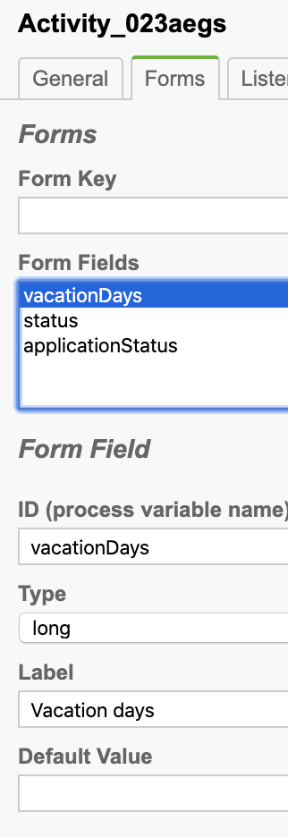
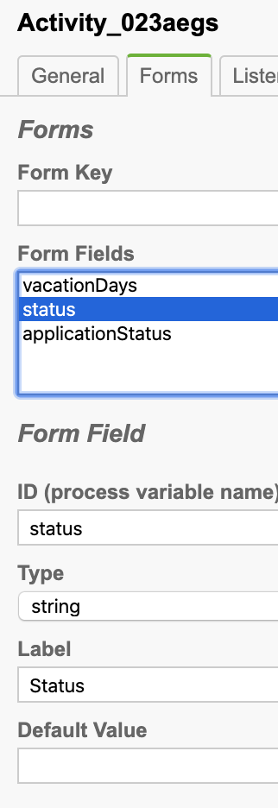
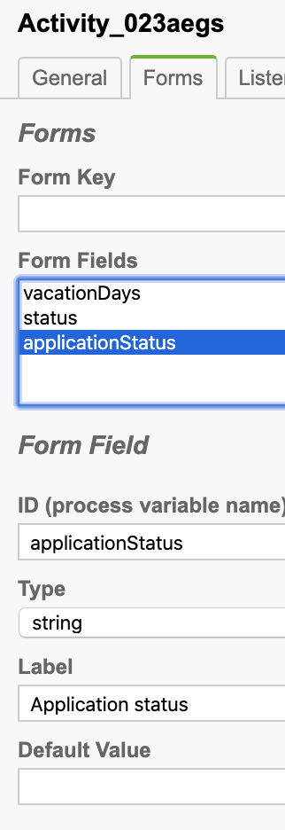
Task form

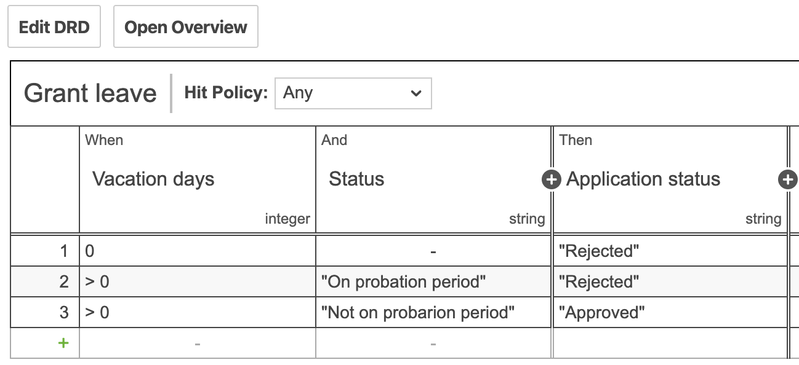
4. Decision table:

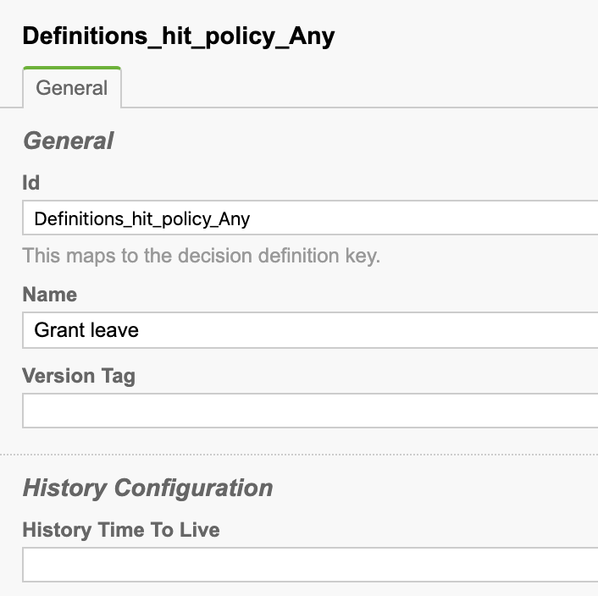
Properties:

Id: Definitions_hit_policy_Any
Name: Grant leave

5. Deploy process definition and decision table.

6. Testing the process definition and DMN

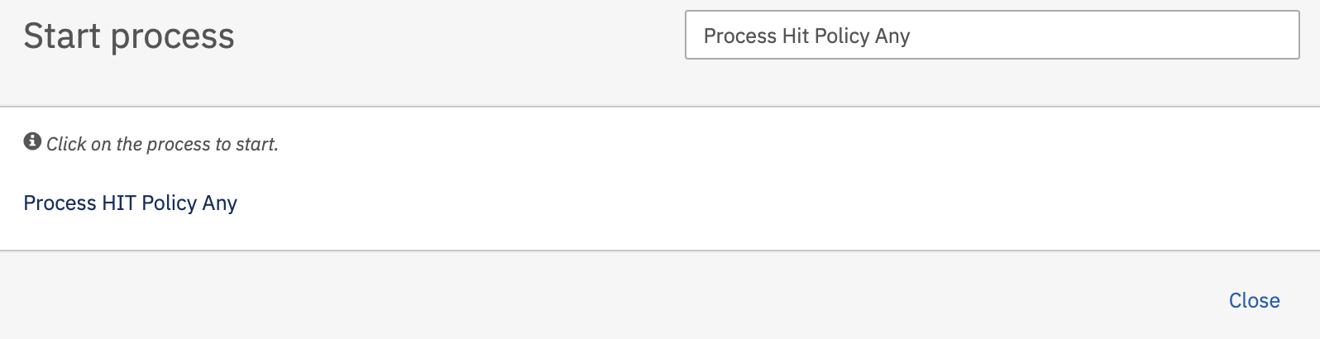
Start the process definition
Hit Process HIT Policy Any and press Start button to start process.

As per process definition, user task Apply leave will get created.
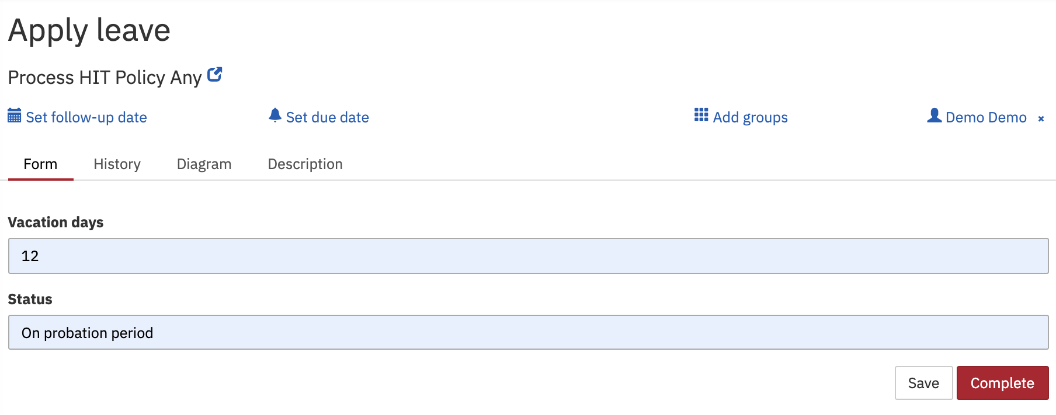
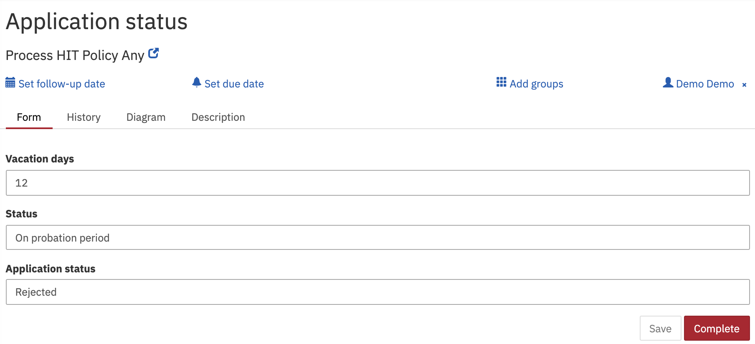
Fill-up the task form and press Complete button and then as per process definition business rule task get executed and will produce single output based on provided data by task and same output result can be viewed on newly created user task Application status.

It can be seen that business rule task has invoked decision table and produces output applicationStatus = Rejected

Note: In decision table if you have two rules satisfied with different output by provided input data then error will be thrown as below

Tomcat console error logs

14-Sep-2020 23:48:20.359 WARNING [http-nio-8080-exec-10] org.camunda.commons.logging.BaseLogger.logWarn ENGINE-REST-HTTP500 org.camunda.bpm.dmn.engine.impl.hitpolicy.DmnHitPolicyException: DMN-03002 Hit policy 'ANY' only allows multiple matching rules with equal output. Matching rules: '[DmnEvaluatedDecisionRuleImpl{id='DecisionRule_0j3lozd', outputEntries={applicationStatus=DmnEvaluatedOutputImpl{id='Output_1', name='Application status', outputName='applicationStatus', value=Value 'Rejected' of type 'PrimitiveValueType[string]', isTransient=false}}}, DmnEvaluatedDecisionRuleImpl{id='DecisionRule_05glf6u', outputEntries={applicationStatus=DmnEvaluatedOutputImpl{id='Output_1', name='Application status', outputName='applicationStatus', value=Value 'Approved' of type 'PrimitiveValueType[string]', isTransient=false}}}]'.

